Screenshot of YEAREND scripts phase 1.5

Step 1: login to fin

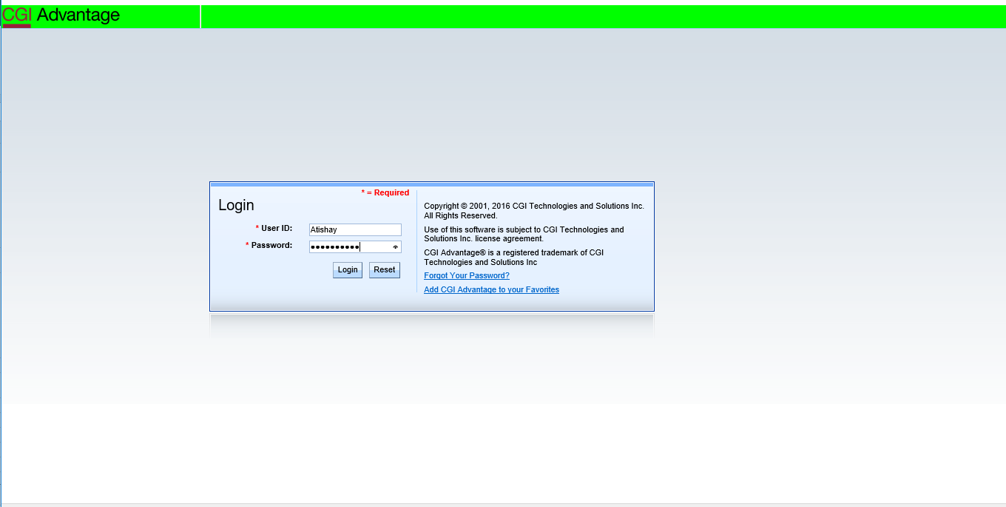

Steps 2: update BADLCON with following parameters.

Reset BUDLCON

Control ID = 40 and 9940

Default Violation = Warn

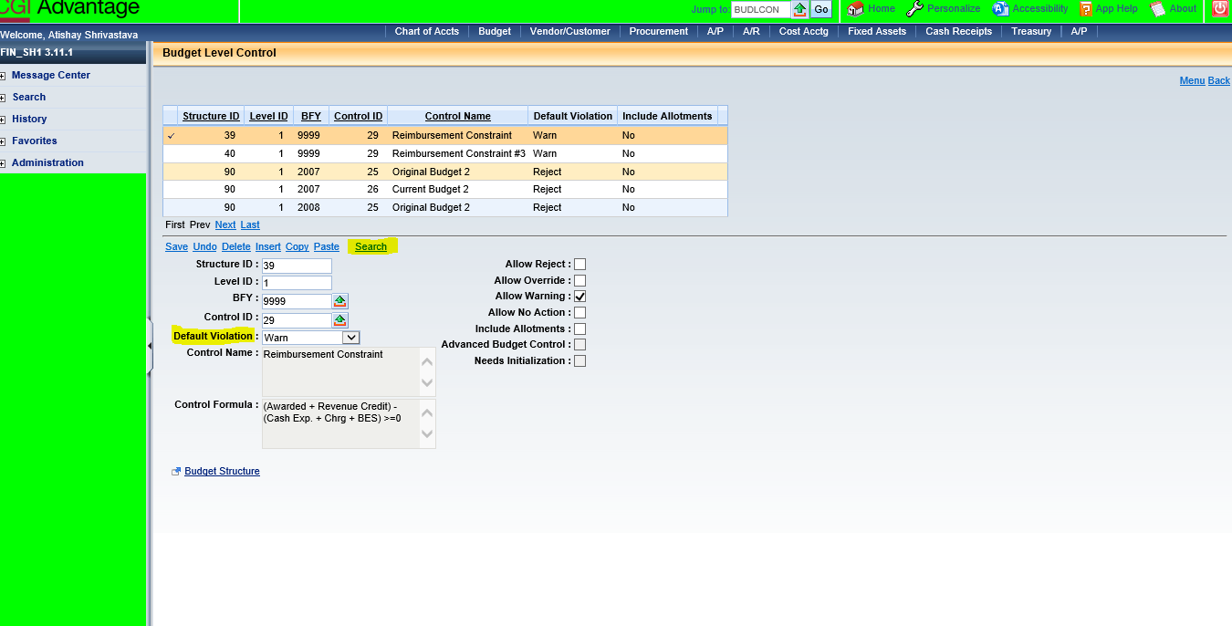

Steps 3: Update ADNT

Update SEQ_NO_RANGE_FROM for 2019 DOC_CD entries on ADNT to at least one record higher than SEQ_LAST_ID for related 2018 records for AD, EFT document codes.

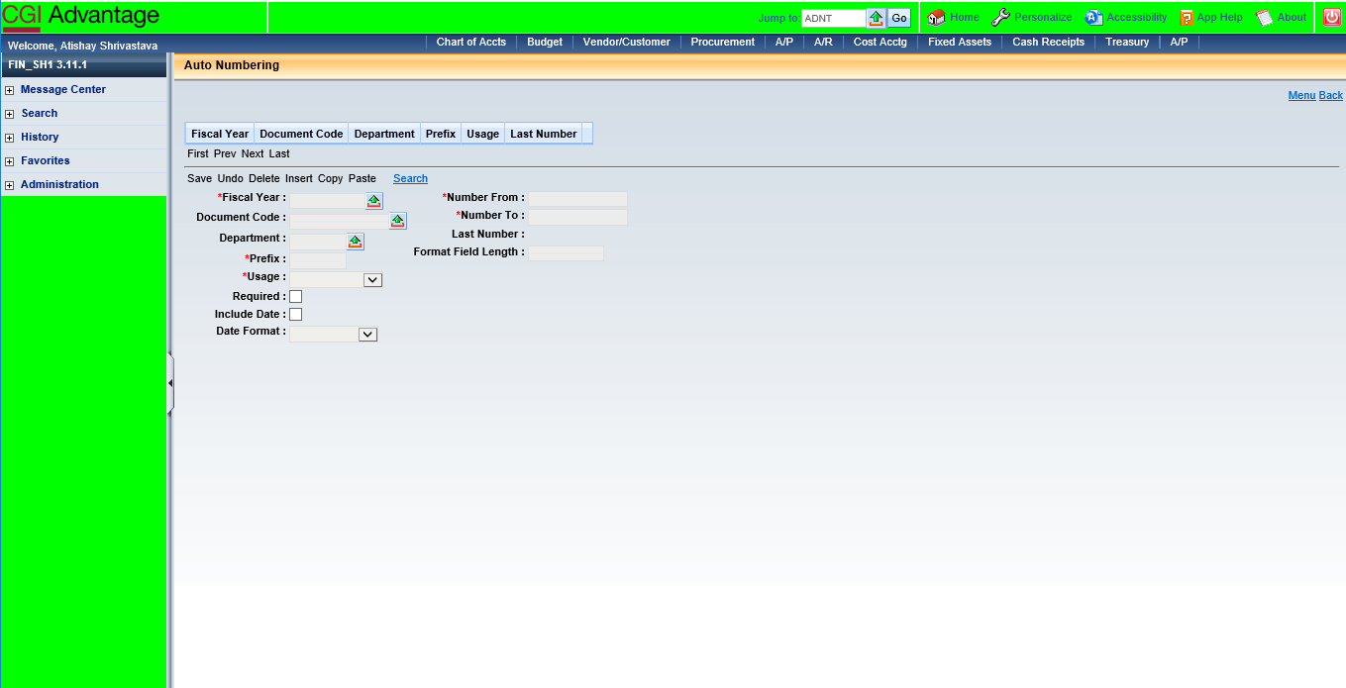

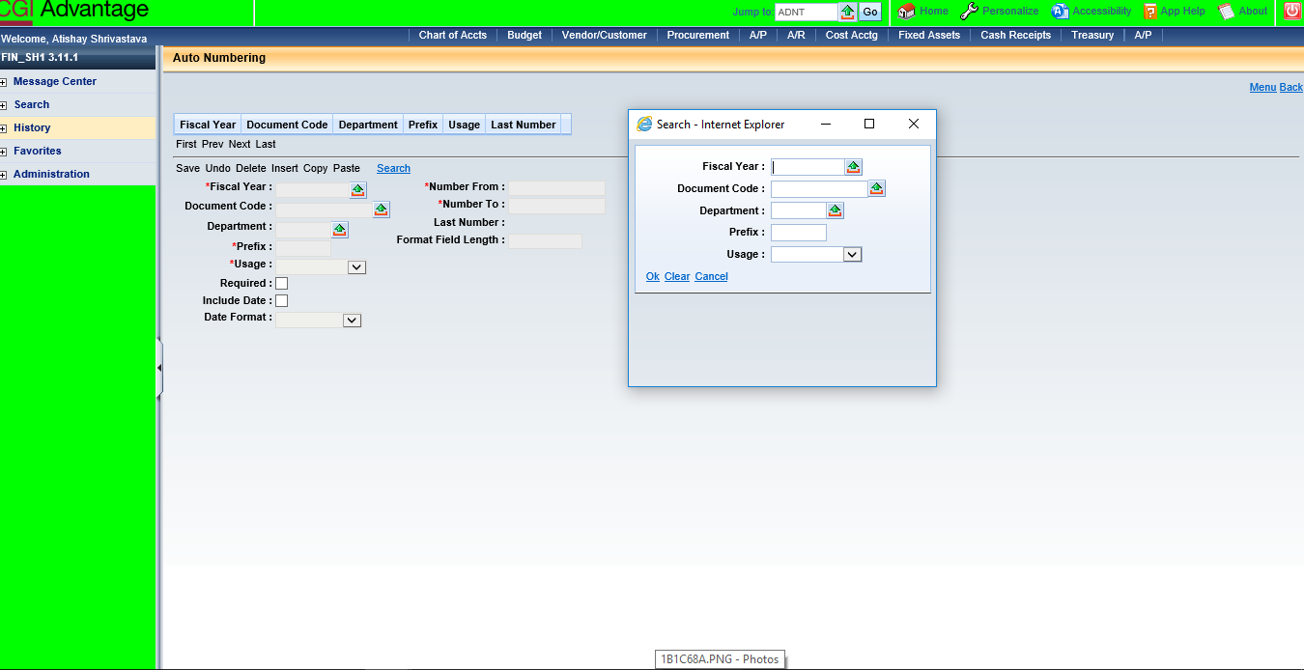

STEPS 4: Update AUTOFANO

Update Default prefix to 2019 (deselect 2018)

